**Something Awesome Report**

z5437869 Alex Lee

# Functionalities

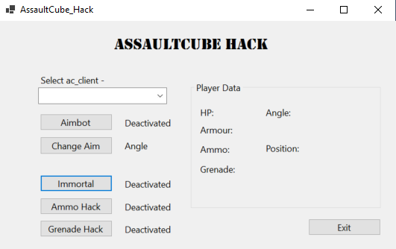

1. Immortal: Permanently fixes the player’s health to 10000. Even if the player is damaged, immediately fixes the player’s health by 10000 in the next tick.
2. Ammo Hack: Permanently fixes the player’s health to 10000. Similar to Immortal, always fixes the ammo amount to 10000.
3. Grenade Hack: Permanently fixes the grenade amount to 10.
4. Data Tracker: Keeps track of the data of the player constantly, including the position and angle, which are not shown on the game window itself.
5. Aimbot: When activated, if a player right-clicks, it immediately fixes its aim to the ‘most suitable player’. There are two algorithms that choose which enemy it should target, where the first only fixes at the enemy closest to the player’s current angle, and the second takes into consideration the distance between the enemies as well.

All of these hacks can be deactivated and activated anytime during the game.

This hack works by manually looking up the values of the Player and the Enemy. Using the saved pointers and the offsets, it searches for and changes the values the user wants to change.

After looking through various different game hacks online I came to the conclusion of using C#, and for a more convenient user experience, I also used an .exe file with buttons, so people could activate the hack by clicking on a few buttons.

Keeping track of the player’s angle (the vision angle player is currently looking at) and the position is necessary for the aimbot to work.

# My Journey

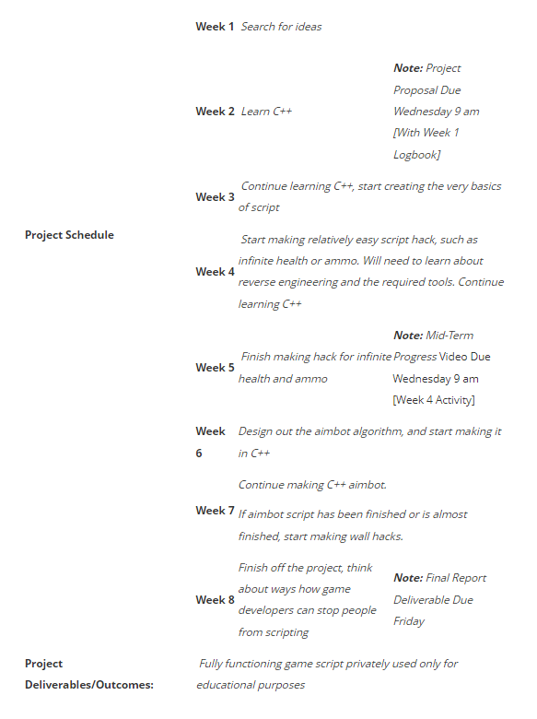The picture on the right shows the original plan that I had thought of before starting this massive project. Unfortunately, I am not the type of person who sticks to the plans when a plan has been set, and my journey in completing this project has been very different to the original plan.

~Week 5: I didn’t code a single line until the start of flex week. I focused more on researching lots of other game hack source codes, and I really wanted to know exactly how game hacks work exactly.

Things I realised were –

1. I had to manually look up values with specific addresses, with the help of a software called CheatEngine.

2. If the program can successfully change and manipulate memory values, 80% of the work will be done.

Week 6: With the information I had learnt from the previous weeks, I found the pointer addresses of the player (pointers are needed because memory addresses become different every time the game is loaded), made software that successfully changed the values of specific addresses we were looking for, and created a window that could successfully manipulate the memory addresses. I decided to use C# because of 2 projects I found on the internet and decided it was no different from C (which I am very familiar with). Other than going outside in the daytime in Brisbane (I was on a trip) I literally spent every single minute on this project throughout the week.

Week 7: After the massive work I did in Week 6, everything seemed very straightforward, until I had to find out the memory addresses of the enemies. Although there is only a single player, there are multiple enemies, and I had to learn about ‘multilevel pointers’. This took a few days, and after finding out they were on a ‘list’ I was a bit done with the project and decided to finish off in Week 8.

Week 8: Now having all the data required to make the aimbot, I had to create an algorithm that calculated the direction, by manually checking how the coordinates worked for this game, and using trigonometry knowledge from high school. With this, I made the aimbot, and also created 2 methods for the aimbot for more versatility for the user.

# Appendix

These are Youtube videos and Github repositories which helped me make this software.

<https://github.com/erfg12/memory.dll/tree/master>

<https://github.com/rohvani/CSGOBot>

<https://github.com/adenosinetp10/AssaultCube-Trainer>

<https://my-repo.tistory.com/>

<https://github.com/PoLaKoSz/AssaultCube-Trainer>

<https://www.youtube.com/watch?v=l5forrVgxTU&ab_channel=xseefox>

<https://www.youtube.com/watch?v=dyx5qcKswVk&ab_channel=Alizer>

<https://github.com/0XDE57/AssaultCubeHack>

<https://www.youtube.com/watch?v=X8m_SqrXK7c&ab_channel=Swashed>

<https://github.com/CloneLTaps/AssaultCubeExternalHack>

<https://www.youtube.com/watch?v=N-XeYurQU1M&ab_channel=HazardEdit>

<https://github.com/organizedgrime/Aimbot/tree/master>

There were also a lot more Google searches, but I cannot provide my entire Google search history for 2 months for the sake of my privacy. Sorry Kyu-Sang!